Confidential Health Information
Grove Chiropractic
Dr. Tyler Vorst, DC
212 W. Sycamore St.
Columbus Grove, OH, 45830
419-659-2271
www.Grovedc.com
Please allow our staff to photocopy your driver’s license and
insurance details. All information you supply is confidential.
We comply with all federal privacy standards. Please print clearly.

Today’s Date (MM/DD/YYYY)

Have you consulted a chiropractor before?
Whom may we thank for referring you? No Yes When?______________ If so, whom?__________________

Your Last Name Your Social Security Number Birth Date (MM/DD/YYYY) Age

Gender
Your First Name Your Middle Name/Initial Male Female Race

Address Marital Status Ethnicity

City State Zip Children Preferred Language

Home Phone Cell Phone Cell Carrier

Email Address Would You Like Text Message Reminders? Yes No

Emergency Contact Emergency Contact’s Phone

Your Occupation

Your Employer Work Phone

Address May we contact you at work?
Yes No

City State Zip Preferred Method of contact?
Home Phone Cell Phone
Work Phone Email
Primary Care Provider’s Name

Insurance Carrier Policy Number

Insured’s Last Name Birth Date (MM/DD/YYYY) Who carries this policy?
Self Spouse Parent

Insured’s First Name Insured’s Middle Name/Initial

Insured’s Employer

Address

City State Zip Employer’s Phone
- The symptom(s) that have prompted me to seek care today include:____________________________________________
Patient Name

_________________________________________________________________________________________________________________
- And are the result of: An accident or injury
Work Auto Other___________________________________________________________
A worsening long-term problem
An interest in: Wellness Nutrition

- Onset (When did you first 4. Duration and Timing (When did it start and how often do you feel it?)
notice your symptoms?) Constant Comes and goes. How often?________________

5. Intensity (How bad are your symptoms)
55
0 10
1 2 3 4 5 6 7 8 9
6. Location (Where does it hurt?) 7. Quality of symptoms (What does it feel like)
Mark the area(s) on the illustration.
- Numbness
- Stiffness
- Dull
- Aching
- Cramps
- Nagging
- Sharp
- Burning
- Shooting
- Throbbing
- Stabbing
- Other_______
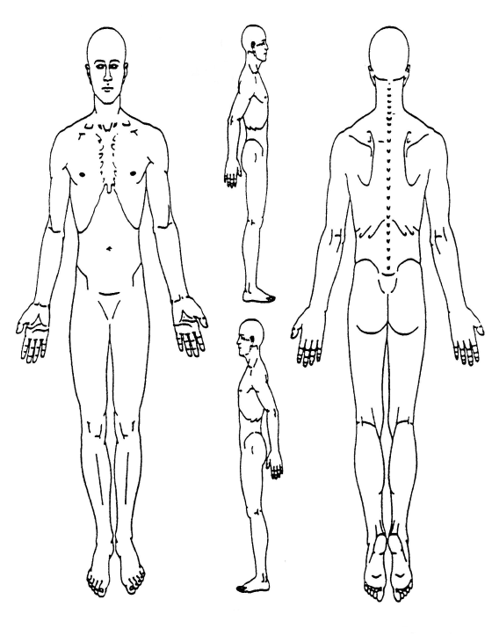
8. Radiation (Does it affect other areas of your body?
To what areas does the pain radiate, shoot, or travel to?)

start?___________________________

9. Aggravating or relieving factors (What makes it better or worse
such as time of day, movements, certain activities, etc.)
What tends to worsen
the problem?________________________________________
What tends to lessen
the problem?________________________________________

10. Prior interventions (What have you done to relieve symptoms?)
Prescription Medication Surgery Ice
Over-the-counter drugs Acupuncture Heat
Homeopathic remedies Chiropractic Other___________________
Physical therapy Massage

11. What else should Grove Chiropractic know about your current condition?____________________________________

_______________________________________________________________________________________________________________

12. How does your current condition interfere with your:

Work or career:__________________________________________________________________________________________

Recreational activities:____________________________________________________________________________________

Household Responsibilities:________________________________________________________________________________

Personal Relationships:_________________________________________________________________________

13. Review of Systems
Chiropractic care focuses on the integrity of your nervous system, which controls and regulates your entire body. Please darken the circle beside any condition you’ve Had or currently Have and initial to the right.

- Musculoskeletal
Had Have Had Have Had Have Had Have Had Have Had Have None
Osteoporosis Arthritis Scoliosis Neck pain Back pain Hip disorders
Knee injuries Foot/Ankle pain Shoulder pain Elbow/wrist pain TMJ issues Poor posture Initials_____

B. Neurological
Had Have Had Have Had Have Had Have Had Have Had Have None
Anxiety Depression Headache Dizziness Pins & Numbness
Needles Initials_____
C. Cardiovascular
Had Have Had Have Had Have Had Have Had Have Had Have None
High blood Low blood High Poor Angina Excessive
pressure pressure cholesterol circulation bruising Initials_____

D. Respiratory
Had Have Had Have Had Have Had Have Had Have Had Have None
Asthma Apnea Emphysema Hay fever Shortness Pneumonia
of breathe Initials_____
E. Digestive
Had Have Had Have Had Have Had Have Had Have Had Have None
Anorexia/ Ulcer Food allergies Heartburn Constipation Diarrhea
Bulimia Initials_____
F. Sensory
Had Have Had Have Had Have Had Have Had Have Had Have None
Blurred vision Ringing in Hearing loss Chronic ear Loss of smell Loss of taste
ears infection Initials_____
G. Skin
Had Have Had Have Had Have Had Have Had Have Had Have None
Skin cancer Psoriasis Eczema Acne Hair loss Rash
Initials_____
H. Endocrine
Had Have Had Have Had Have Had Have Had Have Had Have None
Thyroid issues Immune Hypoglycemia Frequent Swollen glands Low energy
disorders infections Initials_____
I. Genitourinary
Had Have Had Have Had Have Had Have Had Have Had Have None
Kidney stones Infertility Bedwetting Prostate issues Erectile PMS symptoms
dysfunction Initials_____
J. Constitutional
Had Have Had Have Had Have Had Have Had Have Had Have None
Fainting Low libido Poor appetite Fatigue Sudden weight Weakness
gain/loss Initials_____

Past Personal, Family, and Social History
Please identify your past health history, including accidents, injuries, illnesses, and treatments.

14. Illnesses
Please write in any illness you have had in the past or have right now.

______________________________________________________________________________________________________________________________________

______________________________________________________________________________________________________________________________________

______________________________________________________________________________________________________________________________________

15. Operations (Both inpatient and outpatient procedures)
Please write in any operations you have had in the past, and include the approximate year.

______________________________________________________________________________________________________________________________________

______________________________________________________________________________________________________________________________________

______________________________________________________________________________________________________________________________________

16. Injuries
Please write in any injuries or motor vehicle accidents you have had in the past, and include the approximate year.

______________________________________________________________________________________________________________________________________

______________________________________________________________________________________________________________________________________

______________________________________________________________________________________________________________________________________

17. Medications
Please write in any medications or over-the-counter drugs you are currently taking. (If you have a medication list with you, please give it to the receptionist and skip to the next question)

______________________________________________________________________________________________________________________________________

______________________________________________________________________________________________________________________________________

______________________________________________________________________________________________________________________________________

18. Family History
Some health issues are hereditary. Tell Grove Chiropractic about the health of your immediate family members (heart disease, diabetes, cancer, etc.).

______________________________________________________________________________________________________________________________________

______________________________________________________________________________________________________________________________________

______________________________________________________________________________________________________________________________________

19. Social History (Tell Grove Chiropractic about your health habits and stress levels.)
Alcohol use Daily Weekly How much?__________________________________________________________
Coffee use Daily Weekly How much?__________________________________________________________
Tobacco use Daily Weekly How much?__________________________________________________________
Exercising Daily Weekly How much?__________________________________________________________
Pain relievers Daily Weekly How much?__________________________________________________________
Soft Drinks Daily Weekly How much?__________________________________________________________
Water intake Daily Weekly How much?__________________________________________________________
Hobbies:_________________________________________________________________________________________________

20. Activities of Daily Living (How does this condition currently interfere with your life and ability to function?)
No effect Mild effect Moderate effect Severe effect No effect Mild effect Moderate effect Severe effect
Sitting-------------------------- Grocery shopping----------
Rising out of a chair------ Household chores----------
Standing--------------------- Lifting objects----------------
Walking ---------------------- Reaching overhead--------
Lying down------------------ Showering or bathing-----
Bending over--------------- Dressing myself-------------
Climbing stairs------------- Love life------------------------
Using a computer--------- Getting to sleep-------------
Getting in/out of car------- Staying asleep---------------
Driving------------------------- Concentrating----------------
Looking over shoulder--- Exercising---------------------
Caring for family------------ Yard work----------------------

21. What is the major stressor in your life?_________________ 22. How much sleep do you average per night?_____Hours

23. Describe your typical eating habits: Skip breakfast Two meals a day Three meals a day Snacking between meals

Acknowledgements
To set clear expectations, improve communications and help you get the best results in the shortest amount of time, please read each statement and initial you agreement.

Initials_____

Initials_____

Initials_____

Initials_____

Initials_____
I instruct the chiropractor to deliver the care that, in his professional judgment, can best help me in the restoration of my health. I also understand that the chiropractic care offered in this practice is based on the best available evidence and designed to reduce or correct vertebral subluxation and muscle adhesion. Chiropractic is a separate and distinct healing art from medicine and does not proclaim to cure any named disease or entity.

I may request a copy of the Privacy Policy and understand it describes how my personal health information is protected and released on my behalf for seeking reimbursement from any involved third parties.

I grant permission to be called to confirm or reschedule an appointment and to be sent occasional cards, letters, emails, or health information to me as an extension of my care in this office.

I acknowledge that any insurance I may have is an agreement between the carrier and me and that I am responsible for the payment of any covered or non-covered services I receive.

To the best of my ability, the information I have supplied is complete and truthful. I have not misrepresented the presence, severity or cause of my health concern.

If the patient is a minor child, print child’s full name:__________________________________________________________

Signature Date (MM/DD/YYYY)

Doctors Initials
Dr. Tyler Vorst, DC

